INTEGRATED TICKET MANAGEMENT SYSTEM (ITMS)
ITMS provides ability to register any issue related to RCH application. If user is facing any functional or data related issue or they have any new requirement, they can log the issue using this platform that will get reported to RCH team.

How to raise ticket?
Steps mentioned below illustrates, complete workflow of raising the ticket.
- First enter the registered Mobile number to get OTP.
- Once the OTP is verified, user clicks on Raise Ticket button register their issue/suggestions/new requirements etc.
- Whole RCH application is classified in Module, Sub Module and specific pages. E.g. in Data Entry Module, Pregnant Woman Entry is sub module and PG-1 is the form.
- User can raise issue for the respective module where ever they are facing any issue.
- User can also attach the screenshot or any document related to the issue.
- On clicking ‘Submit’ button, a ticket number will be generated than can be used for future reference to track the status.
Steps to follow
- Click on the ‘Raise Ticket’ button from the HomePage.
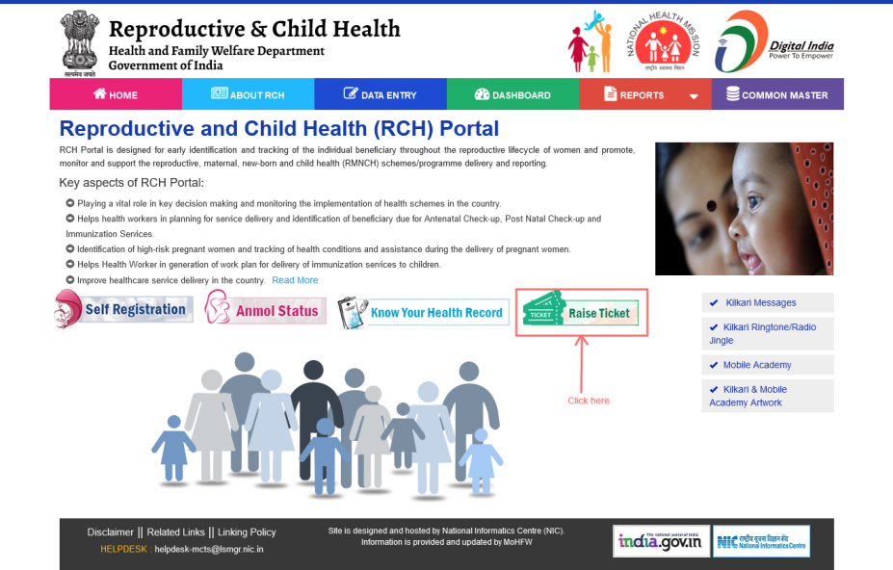
- You redirect to the INTEGRATED TICKET MANAGEMENT SYSTEM https://itms.nic.in/raise-ticket/
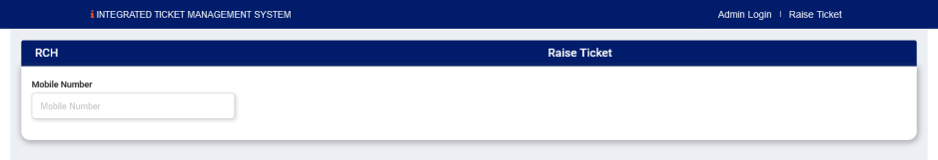
- Enter your registered Mobile Number to get the OTP.
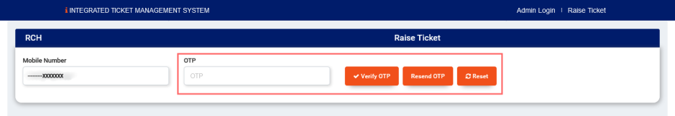
- A detail of User is showing.
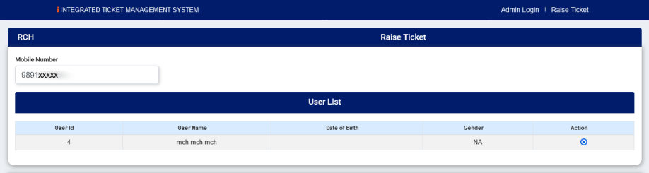
- Click on Action to raise a ticket or check the status of the raised issue.
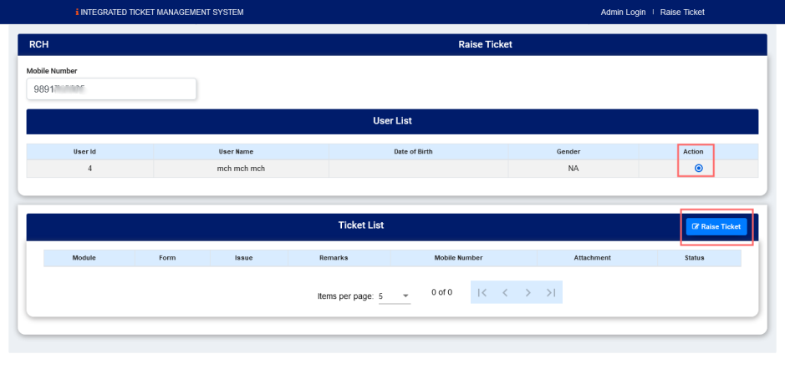
- On clicking on ‘Raise ticket’ button shows
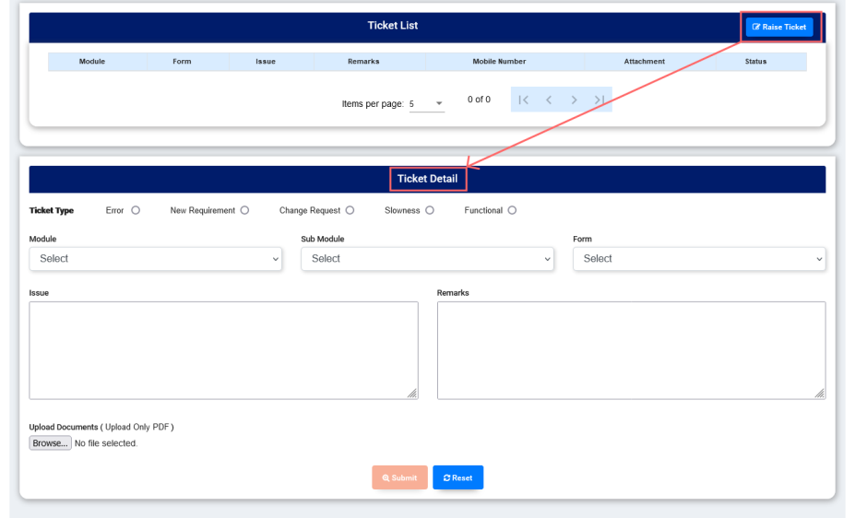

Ticket Detail
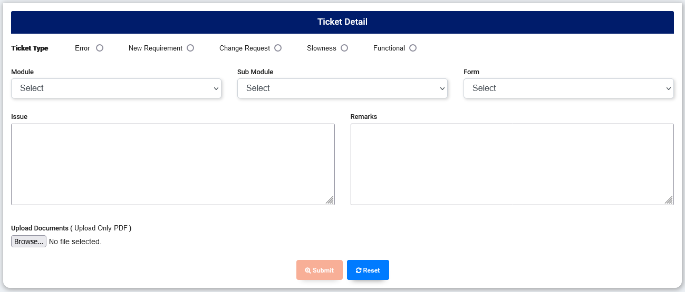
- Ticket type –Radio button shows the type of issue user wants to raise-
- Error – when user facing issue for the respective module
- New Requirement – when user want any new addition in module or sub module
- Change Request – when user want to change their issue type
- Slowness – when the performance, quality of system is operating at a low speed.
- Functional – when there is problem is any module
- Module, Sub Module, Form - whole RCH application is classified in Module, Sub Module and specific pages. E.g. in Data Entry Module, Pregnant Woman Entry is sub module and PG-1 is the form.
- Issue – User can write issues in the given box.
- Remarks – Can be used to provide additional information.
- Upload documents - User can attach the screenshot or any document related to the issue in PDF format
- Submit – After providing all required details; clicking on ‘Submit’ will save issue and display message with ticket number.
- Reset – To be used to reset the page.

